# Autonomous Vehicle Policy: A Survey of all US State Legislation (2012-2019)

## Authored by: Michael Gaunt

## University of California Davis

# Introduction

Autonomous Vehicles (AVs) have become the focus of culture, tech, and transportation research. The implementation of this technology has captured the imagination of the masses, financial speculators, and the tech and automotive industries while jointly piquing the attention of regulators. Despite a real demonstration of technical maturity at scale or understanding AVs legacy system compatibility, claims exist professing the benefits of *AVs with respect to making transportation better*. Regardless of the truthfulness of these claims, one thing is for sure, every day more and more actors are entering this sector, each with their own goals, incentive structures, and time tables.

With massive financial gains at stake, tech and automotive companies are clamoring to be first-movers in the AV industry. From autonomous delivery services to sensor OEMs and everything in between, bets are already being placed as massive amounts of money are being pumped into “AV companies” (Sergeenkov 2019)**.** Given the perceived “winner take all” stakes and the coincidence of maturing AV technology, developers have taken to the streets in droves to test their products. In 2018, Waymo, the AV arm of Google’s parent company, Alphabet, tested over 1.2 million miles in California alone (Arizona being its main testing location) with competitors following suit (MADRIGAL 2019)**.**

While some actors have focused on testing, others already have their sights on clear go-to-market strategies. Very recently, UBER successfully lobbied the state of Florida to allow for the operation autonomous vehicle fleets(Iannelli 2019).This is a notable departure in AV policy as previous legislation focused on the allowance of testing rather than operation of an entire fleet network for business. Yet, despite the efforts of the private sector, it remains to be seen what the impact of autonomous vehicles will be at the network level when the market is saturated – good or bad.

For example, AVs will have sensing, communication, and action speeds which will allow for the forming of platoons – densely packed, connected vehicle groups. Denser packings of vehicles mean less road space for an equivalent number of vehicles, leading to faster traffic flows, less congestion, and less greenhouse gas (GHG) emissions (Thorpe, Jochem, and Pomerleau n.d.) – a good outcome. Alternatively, to avoid steep parking costs AVs could drop-off their owners at an activity location and continue to circulate in traffic with no occupant (deadheading) (Millard-Ball 2019)**.** Pricing as a tool forparking demand management would become useless, as hundreds of vehicles which would normally be out of the stream of traffic would flood the network, leading to increased congestion, lower levels of service, and higher emissions – a bad outcome. Boundless examples exist which hypothesize the utopian or dystopian effects of large-scale AV use, but the true impacts of AVs will likely not be known until actualization.

In response to the dissonance among the research and private sector fervor, states have stepped into a regulatory role. As early as 2012, states have been enacting legislation which either advocates for or blocks AV technology on their roadways. Over the course of the last eight years, more and more states have become legislatively active while already engaged states are expanding upon their already large bodies of legislation. Despite the increased state-level political activity there remains a lack of federal leadership. Both the SELF DRIVE Act (Latta 2017) and AV START Act (Thune 2017), two attempts at the federal level to provide legislative leadership and oversight of AV technology, were met with failure (Nelson 2019)**.** In comparison, other AV legislation such as the Secure 5G and Beyond Act (Cornyn 2019), which prevents the nationalization of 5G networks, a technology vital to vehicle-to-vehicle communications in AVs, and protects telecom company’s privatization of these utilities, will likely be enacted this year.

Due to these complications, the infancy of the AV industry and the technology, and the general political discord which exists today, it is very unlikely any legislative leadership at the federal level regarding AVs. However, without a unified, centralized power prescribing mandates and policies, it then falls to the states to define the operation, testing, and form of AVs. Likely see uncoordinated policies and a patchwork of legislation that tech and automotive companies will have to navigate.

# Analysis

## Overview

As previously asserted, the policy environment resulting from state lead efforts will likely be fragmented and patchwork. This research attempts to highlight regulatory discontinuities which currently exist by examining all proposed state legislation regarding AVs starting in 2012 to current day. This was done by processing the full body of legislation with a natural language processing script written in the statistical language “R”. Through this analysis, actionable data – word counts, term frequency, and topics – were extracted from the text body. Predominant themes in the bills were highlighted by the identification of uncommon words or a high occurrence of commonly associated words e.g. words associated with safety: failsafe, redundant, crash, etc. The workflow used in this analysis is depicted in the below image.

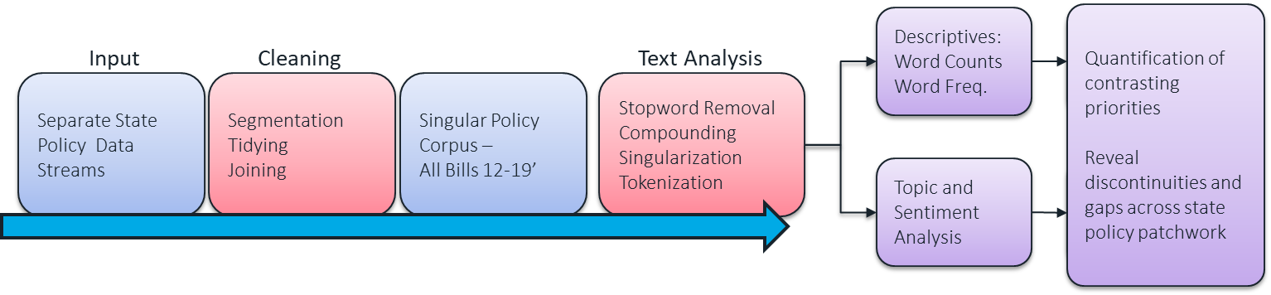

The analytical framework which guided this research can be seen below. First, general descriptive of the data were quantified such as identifying legislatively “active” states, legislatively “consistent” states, enaction vs. proposed bill rates per states, and word counts per state and per bill. twofold; to produce general descriptives of the data and. Second, the research wanted to determine if there were prevalent topics in the policies. Given various typological and text analysis techniques, topics could be compared between bills, states, over time series, and by their enacted, failed, or pending status.



## Data and Tidying

The data used for this research was provided by National Conference of State Legislatures (NCSL). The NCSL is non-partisan origination which collects data on a wide range of subjects meant for policy development. Since 2012, the NCSL has maintained a database of all proposed US state bills pertaining to Autonomous Vehicles. The data is primarily in text format and was analyzed using text analysis techniques via R.

The data in their original formats varied drastically, both in content and from. Legislation dating from 2012 to 2016 were in separate files and legislation from 2017 to 2019 was contained in a single file. Text analysis and computation convention requires all data to conform to a single format, thus all files were “tidied” and restructured to conform with “Tidy Data” standards as defined by Hadley Wickham (Wickham 2015). Given the great degree of variance among the 2012/2016 files and the complexity of developing an R script robust enough to perform this task, these files were restructured by hand in Excel. Alternatively, the 2017/2019 data required segmentation which was performed in R. Individual bills were identified and restructured in a way were bill texts were paired with the appropriate meta-data.

Once in a consistent form, all data streams were merged into a single data frame table (corpus). The policy corpus records each individual bill’s summary text and accompanying meta-data – bill name, state, status, and date it was introduced. Each bill summary text required additional pre-processing in standard text analysis fashion before analysis could be carried out.

The texts were stripped of all punctuation and numerical symbols. Common English stopwords were removed to reduce the overall dimensionality of the corpus as well preventing extraneous findings e.g. counting “the” would skew the word count totals. Further efforts were required to ensure frequently grouped words with specific meanings be properly identify. For example, the survey texts revealed twenty-four different ways to refer to an autonomous vehicle e.g. automated motor vehicle vs. self-driving vehicle vs. driverless vehicle. Grouped words like these were either reduced to a singular abbreviation or compounded together entirely. Finally, singularization was applied to the texts to stem the plural versions of words to the singular version making it easier for important words to be evident in the total word counts.

## Topic Analysis

A focus of this analysis was to identify overarching themes or topics existent in policy text. Framework for topic identification was developed based upon reoccurring patterns/words in the policy corpus. NLP based analysis could reveal deeper insights than performing simple categorization/topic assignment. For instance, this analysis reveals the specific parties who are prescribed authority over AVs. This is a powerful analytical tool, as it can highlight the fractured landscape of state AV policy.

Eight topics of focus were defined posteriori. The topics used for the topic analysis were: authorities, technology, safety, testing, infrastructure, financial, and social (see appendix for more details). Topic count totals per bill were calculated, bills which had a high amount of references to a given topic were primarily focused on said topic.

There are two caveats regarding the development, implementation, and analysis resulting from this methodology. First, judgement calls were made on what should or should not be included in each topic. Development of these topic “buckets” naturally introduce bias into the analysis. Second, the topics themselves are not intrinsically mutually exclusive and there exists many words which could overlap topics. For example, a specific “failsafe device” could fall under both the “safety” and “technology” topics. However, given the constraints of the employed algorithm, words were exclusively assigned to single topics. Further research would likely benefit from addressing this issue in a more robust manner.

# Results and Discussion

AV policy across all US States (12-19’)

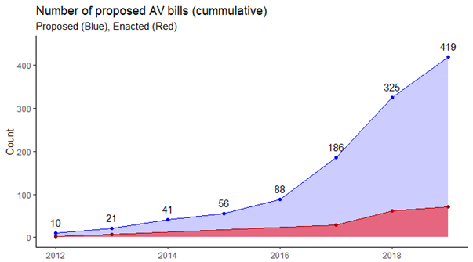The plot to the right displays the cumulative number of all US proposed and enacted policies per year. The ensuing table below shows the top 10 states who have proposed bills (left) and who have enacted bills (right). Interestingly, both plot and table show a large divide in the number of bills that are proposed versus the number which eventually get enacted. The data does not contain any indicators which could potentially explain this inefficiency – whether it is something specific to autonomous vehicles or due to the natural legislative process.

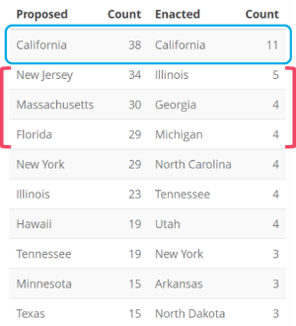This table details this disconnect at the state level. California is the most prolific legislature with close to 40 proposed bills and 11 enacted with and enaction efficiency of 29%. Besides California, there doesn’t seem to be a one-to-on translation between top bill proposing states and enacting states. New Jersey, Massachusetts, and Florida fail to make the 10 ten enacting states list. While Illinois, Tennessee, and New York remain but with much lower efficiency rates, 22%, 21%, 10%, respectively. Georgia, North Carolina, and Michigan are effectively dark horses who round out the top three most enacting states tied Tennessee. There are likely a multitude of reasons for the state reshuffling but again the data does not provide a means for an explanation.

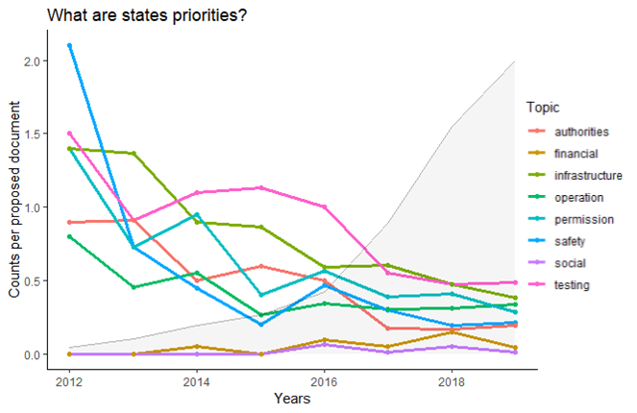The cumulative references of the eight identified topics for all proposed US state AV bills are displayed to the right. The counts were adjusted by dividing by the number of bills proposed for that year, so in actuality the y-axis denotes the average counts per proposed bill per year. There is a clear decreasing trend for most of the topics (all but social and financial). One potential explanation is that once a topic is addressed by a state it no longer requires further legislation. For example, states could initially be concerned with safety, permissions, integration with the built environment, and testing and devote their legislative efforts to ensure proper oversight in these areas. One would see, as the data shows, a large uptick in focus regarding these specific topics as embodied by high topic counts. Attention eventually would be shifted away from these areas if legislators felt that these topics had been sufficiently covered. As one topic falls in priority one would expect another to replace it, this is not seen in the data. Potentially, a topic was missed and excluded from that analysis which was in the 2016:2019 bills.

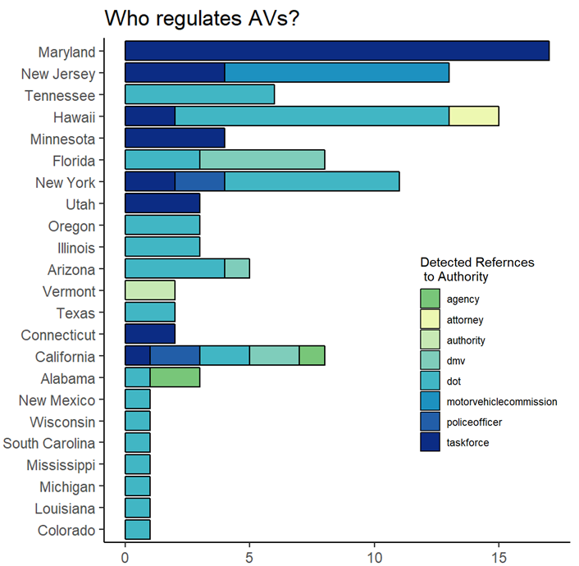The plot below depicts the state variance among prescribed/mentioned authority figures. The three most common authority entities referred to by states were “Task Forces,” the DMV (or similar licensing agencies), and state level department of transportation (DOTs). Maryland and New Jersey alone refer to task forces over twenty times; this can be an attractive option as a task force can be created for the sole purpose of addressing issues related to AVs. Other agencies like state DOTs and the DMV are much larger, well-established agencies but may not be capable of matching the speed and agility of AV development by tech and automotive companies. Notably, California refers to sources of authority shy of ten times where other states like Maryland, New Jersey, and Hawaii make this appeal fifteen times each. As discussed early, California has proposed and enacted substantially more bills than other states but do not have proportional mentions of authority figures. This could suggest that California, a significant testing ground for AVs and the home of many AV companies, is less concerned with defining an authoritative oversight over AVs rather than it is with testing.

## Thee State Snapshot

California, New Jersey, and Georgia were chosen to perform a deeper analysis on. California was chosen for its sizeable activity in the development of AVs and the shear amount of legislation it has both proposed and enacted. New Jersey and Georgia were seemingly odd cases, as New Jersey had proposed many bills but enacted very few and visa versa for Georgia. These two states are juxtaposed to each other as the pair display very different levels of efficiency regarding the proposition and enaction of AV policies.

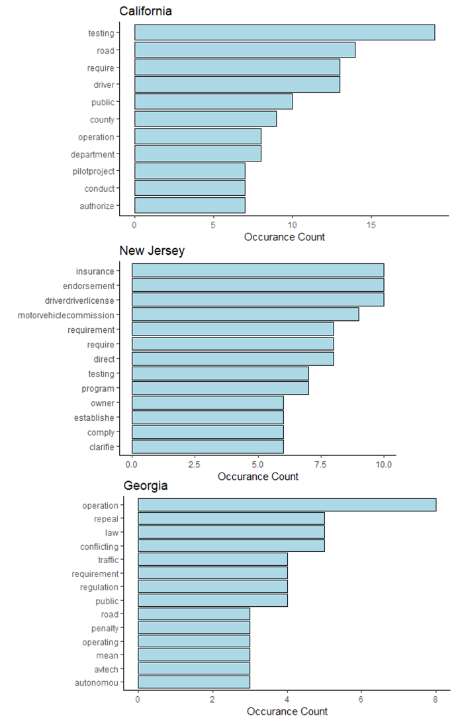The three plots to the right detail the top ten words returned from the analysis of California’s, Georgia’s and New Jersey’s autonomous vehicle policies. California is clearly focused on testing, mentioning both the word “testing” and “pilot projects” (testing) roughly 25 combined times. In addition, California refers to “public”, “county”, and “roads” more than 35 times. This is an important detail to note as “testing” highly correlates to the need to specific where an AV can operate. New Jersey, on the other hand, tends to focus on the practicalities associated with AV ownership, referring to “insurance”, “driver’s license”, and the states Motor Vehicle Commission (like a DMV).

The legislative misalignment between these three states is further indicated by the above plot which details the cumulative occurrences the eight identified AC policy topics. California displays a clear emphasis on testing, safety, and integration with the built environment but proportionally less emphasis on matters of authority or direct references to onboard technology and how the vehicles may operation Similar, to California, New Jersey focuses on testing as well but shows more attention towards permission and defining authority over AVs. This contrast could reflect the fact that most of the AV development and testing occurs in California, and the state may be less inclined to stifle this flourishing industry for a multitude of reasons. Georgia has focused on the technical aspects of AVs, addressing how AVs operate on and integrate with their current infrastructure.

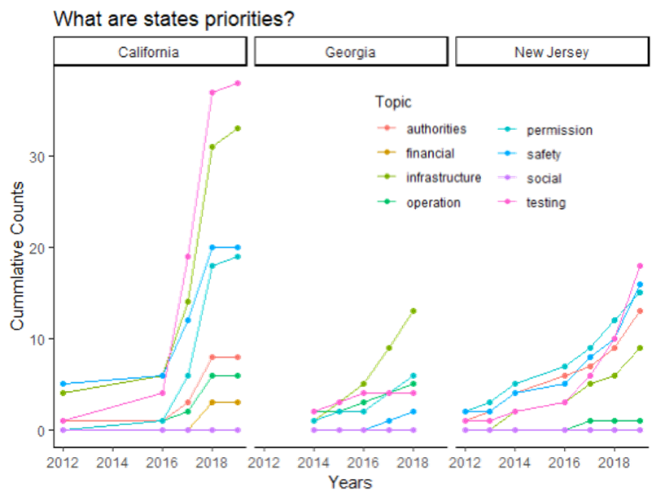The rate at which all three states topics are being counting is also noteworthy. California and New Jersey were both first-movers and started proposing AV legislation in 2012. New Jersey, unlike California, has consistently proposed legislation every year to date where the Golden State had a three-year legislative hiatus from 2013:2015. In 2016, California had a policy explosion which has not stopped. Alternatively, New Jersey seems to have an increasing, albeit slowly, policy rate, with “Operation”, “Testing”, “Safety”, and “Permissions” counts increasing in unison with one another.

# Conclusions and Recommendations

The differences in state policy topics as quantified by this analysis exemplifies the deep divide between state autonomous vehicle policies. Since this analysis was implemented, state legislatures have proposed over four hundred bills as compared to two failed bills at the federal level. This stark contrast is likely a symptom of multiple factors; a partisan political climate, uncertainty regarding the safety of AVs, their impact on transportation networks, and their impact on the economy. The unwillingness or inability of the federal government to pass AV legislation will only further exasperate the issues identified by this research.

# Bibliography

Cornyn, John. 2019. “Text - S.893 - 116th Congress (2019-2020): Secure 5G and Beyond Act of 2019.” https://www.congress.gov/bill/116th-congress/senate-bill/893/text.

Iannelli, Jerry. 2019. “Florida Legislature Passes Bill Legalizing Self-Driving Uber Cars | Miami New Times.” Miami New Times. 2019. https://www.miaminewtimes.com/news/florida-legislature-passes-bill-legalizing-self-driving-uber-cars-11161818.

Latta, Robert E. 2017. “H.R.3388 - 115th Congress (2017-2018): SELF DRIVE Act.” https://www.congress.gov/bill/115th-congress/house-bill/3388.

MADRIGAL, ALEXIS C. 2019. “The Latest Self-Driving-Car Statistics From California - The Atlantic.” The Atlantic. 2019. https://www.theatlantic.com/technology/archive/2019/02/the-latest-self-driving-car-statistics-from-california/582763/.

Millard-Ball, Adam. 2019. “The Autonomous Vehicle Parking Problem.” *Transport Policy*. https://doi.org/10.1016/j.tranpol.2019.01.003.

Nelson, Katrina. 2019. “The Federal Regulations Governing Autonomous Vehicles.” The National Law Review. 2019. https://www.natlawreview.com/article/autonomous-vehicle-federal-regulation.

Sergeenkov, Andrey. 2019. “Competition in the Autonomous Vehicle Industry Is Heating Up.” Hackernoon. 2019. https://hackernoon.com/competition-in-the-autonomous-vehicle-industry-is-heating-up-22524d71ca5.

Thorpe, Chuck, Todd Jochem, and Dean Pomerleau. n.d. “Automated Highways And The Free Agent Demonstration.” Accessed May 21, 2019. https://www.ri.cmu.edu/pub_files/pub2/thorpe_charles_1997_1/thorpe_charles_1997_1.pdf.

Thune, John. 2017. “S.1885 - 115th Congress (2017-2018): AV START Act.” https://www.congress.gov/bill/115th-congress/senate-bill/1885.

Wickham, Hadley. 2015. “Tidy Data.” *Journal of Statistical Software*. https://doi.org/10.18637/jss.v059.i10.

# Appendix

## Topics used for topic analysis

TESTING: trial, tests, testing, test, tentative, study, report, remote human operator, programs, program, pilotprogram, pilot, operator, human operator, demonstration, certification program.

SAFETY: warning, tolerant, tolerance, standards, safety, safegard, safe, performance, insurance, injury, injuries, incidnets, incident, impair, impacts, impact, harm, faults, fault, fail-safe, fail safe, fail, equipped, equip, destroy, damage, crashes, crash, collisions, collision, accidents, accident.

OPERATION: wireless, transparency, security, rideshare, record, protected, protect, privacy, platooning, platoon, multimodal, mobility, microtransit, maas, logging, log, iot, internet of things, identity, driverassistive, data, cybersecurity, cybercrimes, cybercrime, connectivity, communicationdevices, charging, caravan, boundary, boundaries, border, avtech, avtech, ads, adaptive, abs.

AUTHORITIES: vehicleservicesdivision, vehicleservicesdepartment, vehicleservices, transitauthority, taxcommission, taskforce, regulators, regulator, registryofmotorvehicles, policeofficer, police, officer , officeofmotorvehicles, motorvehiclelicensingsystem, motorvehiclelicensingdivision, motorvehicledivision, motorvehiclecommission, motorvehiclebureau, motorvehicleadministration, driverservicesprogram, driverservicesdirectorate, driverservicesdepartment, driverlicenseservices, driverlicensedivision, driverandvehicleservices, driverandmotorvehicleservices, dps, dot, dmv, divisionofvehicles, divisionofmotorvehicles, divisionofdriverlicensing, depatment , departmentofstate, departmentofrevenueandtaxation, departmentofrevenue, departmentofpublicsafety, departmentofmotorvehicles, departmentoflicensing, departmentofhighwaysafetyandmotorvehicles, departmentofdriverservices, commissioner , commission, bureauofmotorvehicles, authority, attorney, agency.

PERMISSIONS: support, rules, rule, revoke, restriction, restrict, prohibit, prohibition, prevent, permission, penalty, penalize, limit, jurisdictions, jurisdiction, impose, hinder, fine, endorsement, encourage, driverlicensed, driverlicense, citations, citation, certification, authorize, approval, appropriate, allow.

INFRASTRUCTURE: transit, turnpike, trafficcontrol, traffic, streets, street, signals, signal, roadways, roadway, roads, road, public, network, interstates, interstate, infrastructure, highways, highway, freeways, freeway, congestion, bridges, bridge.

SOCIAL: wastewater, university, sustainability, marju, health, green, equity, environment, education, disadvantaged, disadvantage, disability, disabilities, disabilities, community, college.

FINANCIAL: taxes, tax, revenue, money, insurers, funds, fund, finance, commercial, commerce, business, budget, bank, banks.